**GUJARAT TECHNOLOGICAL UNIVERSITY**

Chandkheda, Ahmedabad

Affiliated

 

**SARDAR VALLABHBHAI PATEL INSTITUTE OF TECHNOLOGY**

**A**

**Project Report**

**On**

**ARTIFICIAL INTELLIGENT CHATBOT FOR CAREER GUIDANCE**

*Under* subject of

DESIGN ENGINEERING – IA

B. E. II, Semester – III

(Computer Branch)

Submitted by:

Group:

Sr. Name of student Enrolment No.

1. MEET BHAVSAR 170410107007

2. PRIYANKA GHIYA 170410107019

3. VATSH GHANDHI 170410107018

4. AARTI CHAVDA 170410107014

PROF. HIREN PATEL

(Faculty Guide)

DR. NEHA SONI

Head of the Department

Academic year

(2018-2019)

Contents

1. Introduction
2. AEIOU framework
3. Mind mapping
4. Empathy Mapping canvas
5. Ideation Canvas
6. Product Development canvas
7. LNM Canvas
8. Prototype(Flow diagram)
9. Conclusion
10. **INTRODUCTION :--**

CBOT group members are as follows :

Sr. Name of student Enrolment No.

1. MEET BHAVSAR 170410107007

2. PRIYANKA GHIYA 170410107019

3. VATSH GHANDHI 170410107018

4. AARTI CHAVDA 170410107014

* Our domain of work is artificial intelligence.
* We all team-member took part continuous in our all activity and participate in hall decisions or ideas taken by the group member. We all decided then topic as per the view of all the group member and decided to work on “ARTIFICIAL INTELLIGENT CHATBOT “. This chatbot works for the specific purpose, that is for “CAREER GUIDANCE”.
* Our guide for this project is Mr. Hiren Patel. He gave us the clear idea for our project. Make us motivate to select this topic as Artificial intelligence is the growing technology of this new area. We express deep sense of gratitude to his guidance, suggestions and expertise at every stage.
* We have made the project for the freshers students after passing 10th or 12th standard. The students who face problems regarding which field to be selected after 10th, whether science or commerce or arts. Also students passing after 12th are not clear about their interest or are too much confused about selecting any stream.
* Hence the main aim of our project is to help the students to have clear idea of each field and to decide and select the stream as per their interest.

**2. AEIOU FRAMEWORK :**

1. **Activities : -**

* COUNSELLING
* DISCUSSING STUDENTS PROBLEMS
* GUIDANCE REGARDING EACH BRANCH
* CONDUCTING SEMINAR
* ASSIGNMENT

1. **Environment :-**

* SCHOOL
* HOME
* INSTITUTES
* AUDITORIUM

1. **Interaction :-**

* TEACHERS
* STUDENTS
* PRINCIPAL
* FACULTIES
* PARENTS

1. **Objects :-**

* What components are involved..?

* LAPTOP
* MIC
* INTERNET
* NETWORK
* MOBIILE
* DESK

1. **Users :-**

* Who are present roles & responsibilities..?

* SSC PASS
* UNDER GRADUATE
* STAFF MEMBERS
* PRINCIPAL
* FACULTIES
* TAECHERS
* 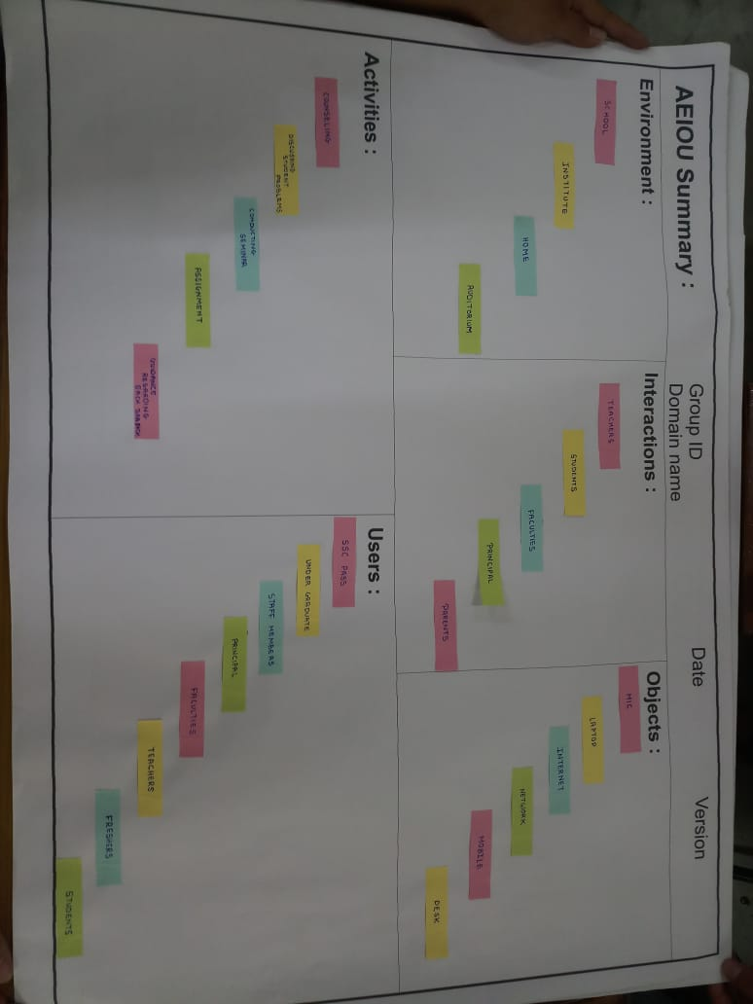FRESHERS
* STUDENTS

**Figure of AEIOU canvas**

**MIND MAPPING**

MIND MAPPING IS A VISUAL REPRESENTATION OF INFORMATION THAT INCLUDES A CENTRAL IDEA SURROUNED BY CONNECTED BRANCHES OF ASSOCIATED TOPICS. IT MAPS OUT THE IDEA SUCH THAT IT IS EASY TO EXPLAIN AS WELL AS EASY TO UNDERSTAND.

A MIND MAPPING IS A GRAPHICAL WAY TO REPRSENT IDEAS AND CONCEPTS. IT IS A VISUAL THINKING TOOL THAT HELPS STRUCTURING INFORMATION, HELPING YOU TO BETTER ANALYZE , COMPREHEND, SYNTHESIZE, RECALL AND GENERATE NEW IDEAS.

MIND MAPPING IS A SIMPLE TECHNIQUE FOR DRAWING INFORMATION IN DIAGRAMS, INSTEAD OF WRITING IN SENTENCES.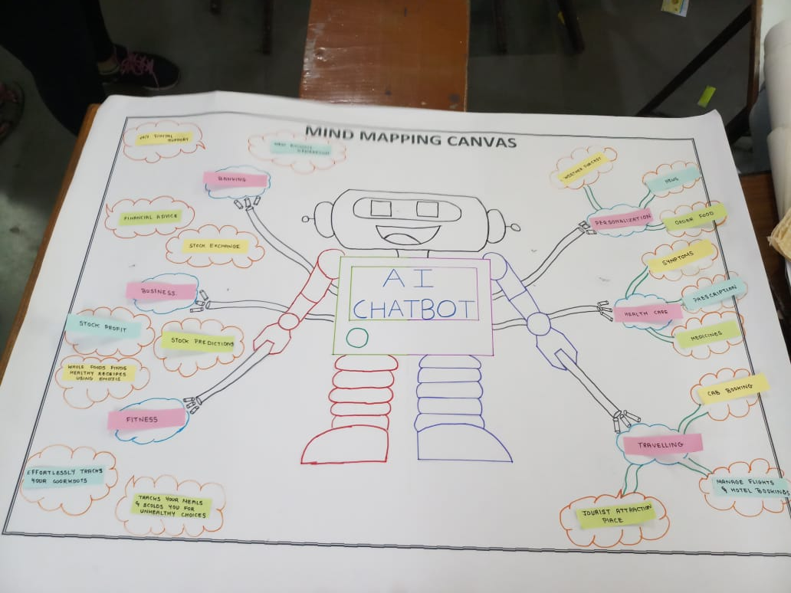

**Figure of mind mapping**

**EMPATHY MAPPING**

AS AN ENGINEERS, IT IS OUR JOB TO ADVOCATE ON BEHALF OF THE USER. HOWEVER, IN ORDER TO DO IT, NOT ONLY MUST WE DEEPLY UNDERSTAND OUR USERS, BUT WE MUST ALSO HELP OUR COLLEAGUES UNDERSTAND THEM AND PRIORITIZE THEIR NEEDS.

EMPATHY MAPS, WIDELY USED THROUGHOUT AGILE AND DESIGN COMMUNITIES , ARE A POWERFUL , FUNDAMENTAL TOOL FOR ACCOMPLISHING BOTH.

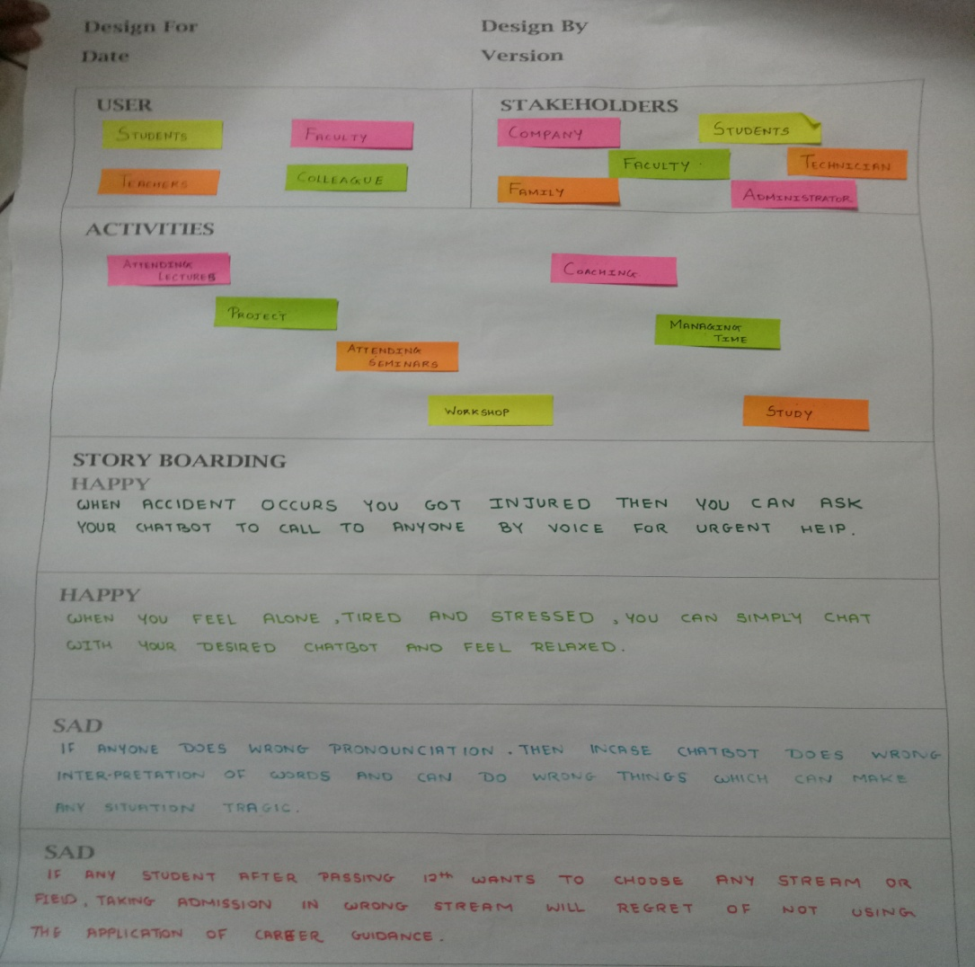

EMPATHY CANVAS HAS FOUR PARTS :

1. USERS
2. STAKEHOLDERS
3. ACTIVITIES
4. STORY BOARDING

**USERS**

USERS ARE THE DIRECT OR MAIN UTILIZER OF THE PROJECT.

SO FOR OUR PROJECT OUR USERS ARE AS FOLLOW:

1. STUDENTS
2. FACULTY
3. COLLEAGUE
4. TEACHER

**STAKEHOLDERS**

STAKEHOLDERS ARE THE INDIRECT USERS OF OUR PROJECT WHICH ARE AFFECTED BY THE USERS.

SO FOR OUR PROJECT THE STAKEHOLDERS ARE :

1. COMPANY
2. STUDENTS
3. FACULTY
4. FAMILY
5. TECHNITION
6. ADMINISTRATOR

**ACTIVITIES**

THE ACTIVITIES INCLUDE THE BASIC ACTIVITIES OF THE STAKEHOLDERS.

**SO OUR PROJECT CONSISTS OF FOLLOWING ACTIVITIES:**

1. ATTENDING LECTURES
2. PROJECT
3. ATTENDING SEMINARS
4. WORKSHOP
5. COACHING
6. MANAGING TIME
7. STUDY

**STORY BOARDING**

STORY BOARDING CONSISTS OF TWO PARTS HAPPY STORY AND SAD STORY. STORIES BASED ON USER EXPERIENCES ARE STATED IN THE CANVAS. IT DESCRIBES HOW THE CHATBOT HELPED THEM IN THE SITUATIONS AND WHAT PROBLEMS THEY FACED WHEN THE CHATBOT WAS NOT THERE.

**IDEATION CANVAS**

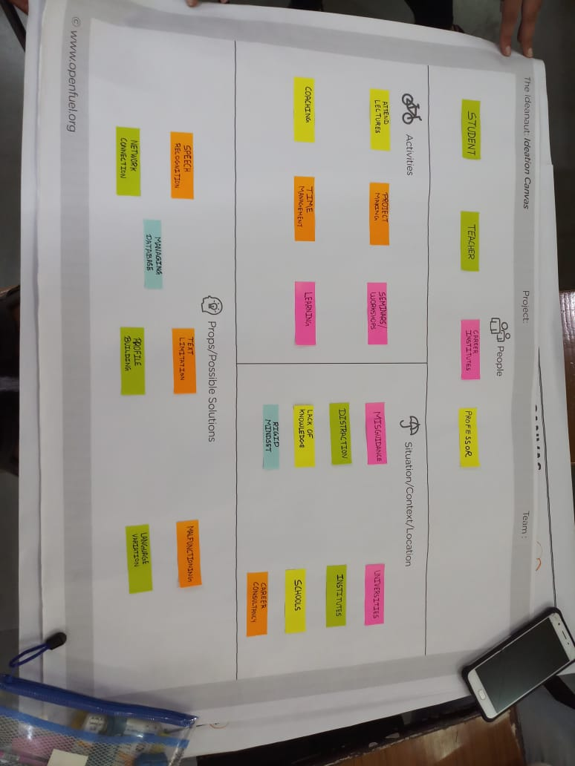IN IDEATION CANVAS , YOU HAVE TO CARRY OUT WHICH TYPE OF ACTIVITIES IS RELATED TO YOUR PROJECT AND PEOPLE? WHAT IS SITUATION AND LOCATION REGARDING TO ACTIVITIES ?

This includes

**PEOPLE :**

1. STUDENT
2. TEACHER
3. CAREER INSTITUTES
4. PROFESSORS

**ACTIVITIES :**

1. ATTENDING LECTURES
2. PROJECT MAKING
3. SEMINARS AND WORKSHOPS
4. COACHING
5. TIME MANAGEMENT
6. LEARNING

**SITUATION/CONTEXT/LOCATION :**

**SITUATION**

1. MISGUIDANCE
2. DISTRACTION
3. LACK OF KNOWLEDGE
4. RIGID MINDSET

**LOCATION:**

1. UNIVERSITIES
2. INSTITUTES
3. SCHOOLS
4. CAREER CONSULTANCY

**PORPS/POSSIBLE SOLUTIONS:**

**PROBLMES :**

1. SPEECH RECOGNIZATION
2. TEXT LIMITAIONS
3. MALFUNCTIONING
4. NETWORK CONNECTIOPROFILE BUILDING
5. LANGUAGE VARIATION
6. NETWORK CONNECTIOPROFILE BUILDING
7. LANGUAGE VARIATION
8. MANAGING DATABASE

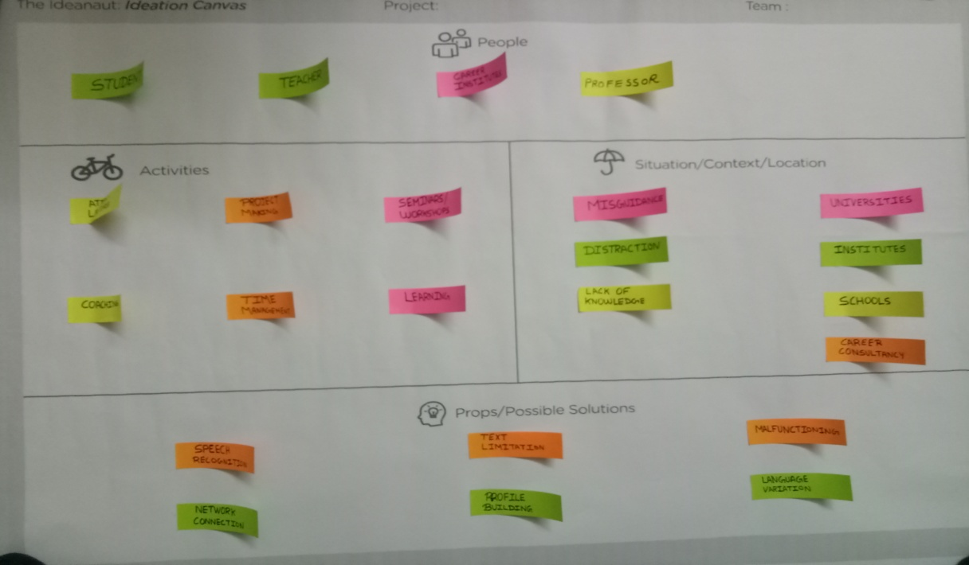

**FIGURE OF IDEATION CANVSAS**

**PRODUCT DEVELOPMENT CANVAS**

PRODUCT DEVELOPMENT IS THE PROCESS OF DESIGNING, CREATING AND MARKETING NEW PRODUCTS OR SERVICES. IT INVOLVES GETTING NEW PRODUCT TO THE MARKET.THE NEED OF THE CHATBOT IS DESCRIBE HERE. WHAT PROBLEMS WERE FACED BY THE USERS WHEN THE CHATBOT WAS ABSENT AND TO OVERCOME THE PROBLEMS THIS CHATBOT WAS MADE, IS CONSIDERED AS PURPOSE OF THE PRODUCT.

**PURPOSE**

1. CAREER GUIDANCE
2. PRECISE DECISION MAKING
3. EFFICIENT
4. UPGRADED COURSES
5. AI LEARNING
6. AVAILABLE COURSES

**PEOPLE**

1. STUDENT (FOR SELECTING STREAMS)
2. PROFESSORS (FOR GUIDING STUDENTS)
3. CAREER COUNSELLING (FOR STUDENT COUNSELING)

**PRODUCT EXPERIENCE**

THE FEELING/EMOTIONS EXPERIENCED BY THE USERS ON USING THE PRODUCT.

1. USER FRIENDlY
2. PRECISE DECISION MAKING
3. CONVENIENCE
4. NON TEDIOUS

**PRODUCT FUNCTIONS**

FUNCTIONS ARE BROAD LEVEL ACTIONS OF THE PRODUCT. OUR PRODUCT HAS THE FOLLOWING FUNCTIONS:

1. HUMAN MACHINE INTERFERENCE
2. ASSURANCE
3. DATA MONITORING
4. AUTHORIZATION

**PRODUCT FEATURES**

FEATURES ARE SPECIFIC WAYS IN WHICH THE FUNCTIONS ARE SUPPORTED .

1. INTERATION
2. CONVERSATIONAL ARCHIVES
3. VOICE RECOGNIZATION
4. EMOTIONALLY INTELLIGENT
5. ANALISE USER’S DATA

**COMPONENTS**

COMPONENTS ARE THE DEVICES OR SERVICES WHICH WE USED TO BUILD THE PRODUCT AND ALSO ON WHAT THE PRODUCT IS GOING TO RUN OR OPERATE.

**HARDWARE COMPONENTS :**

1. LAPTOP
2. SPEAKER
3. MIC
4. KEYBOARD AND MOUSE

**SOFTWARE COMPONENTS :**

1. DATABASE
2. ARTIFICIAL INTELLIGENCE
3. CHATBOT
4. APPLICATION SOFTWARE
5. WEB SERVER
6. WEB BROWSER
7. MACHINE LEARNING
8. NATURAL LANGUAGE PROCESSING

**PLATFORM BASE :**

1. HTML
2. CSS
3. PHP

**CUSTOMER REVALIDATION**

SOME SOLUTION CAN SOLVE THE PROBLEM AND YET NOT MAKE THE USER FEEL COMFORTABLE OR GOOD. REVALIDATIONS CHECKS WHETHER IF THE USER EXPERIENCE YOU DEFINED EARLIER IS BEING FULFILLED BESIDES THE PROBLEM BEING SOLVED.

1. INTERNET ACCESSS
2. AUTHORIZATION
3. FRAME LAYOUT

**REJECT/REDESIGN/RETAIN**

RESIGN MEANS RE-CREATION THE PRODUCT WHICH ENHANCES THE USER EXPERIENCE AND MAKES IT COMFORTABLE FOR THE USERS TO USE IT BY REJECTING THE UNWANTED FEATURES AND RETAINING THE FEATURES AND MAKING MORE USER FRIENDLY AND EFFICIENT.

1. UPGRADATION

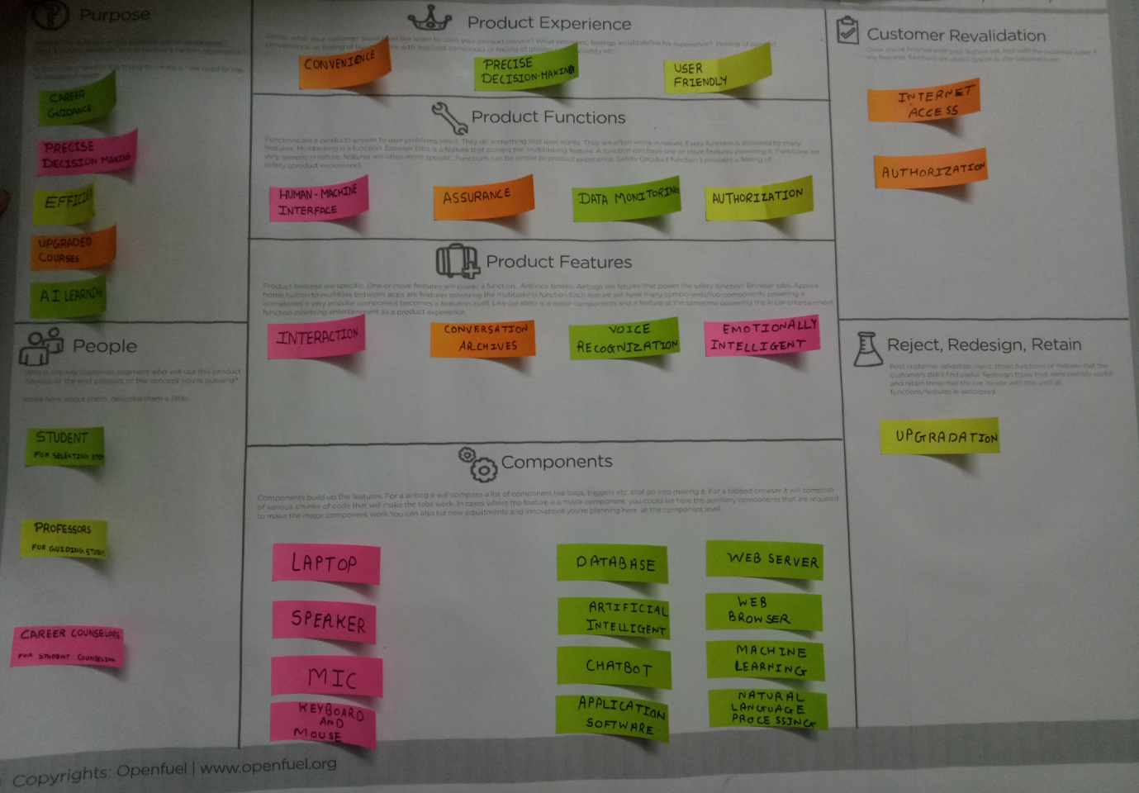

**PURPOSE / PRODUCT CONCEPT CANVAS**

1.CAREER GUIDANCE

2. AVALABLE COURSES

3. PRECISE INFORMATION

**DURING BE II / STAGE I**

1. **APPLICABLE STANDARDS AND DESIGN SPECIFICATIONS / PRINCIPLES AND EXPERIMENTS**
2. INTERACTIVE SYSTEM
3. DECISION MAKING

**2. TOOLS / METHODS / THEORIES / APPLICATION PROCESS INVOLVED**

1. ARTIFICIAL INTELLIGENCE

2. NLP

**3. SOFTWARE / SIMULATION / SKILL / MATHEMATICAL REQUIREMENT**

1. PROGRAMMING

2. ALGORITHMS

3. MY SQL PHP

**4. COMPONENT MATERIALS STRENGTH CRITERIA ( EXPLORATION – VARIETIES / TESTING REQUIRMENTS )**

1. MIC

2. VOICE RECOGNITION

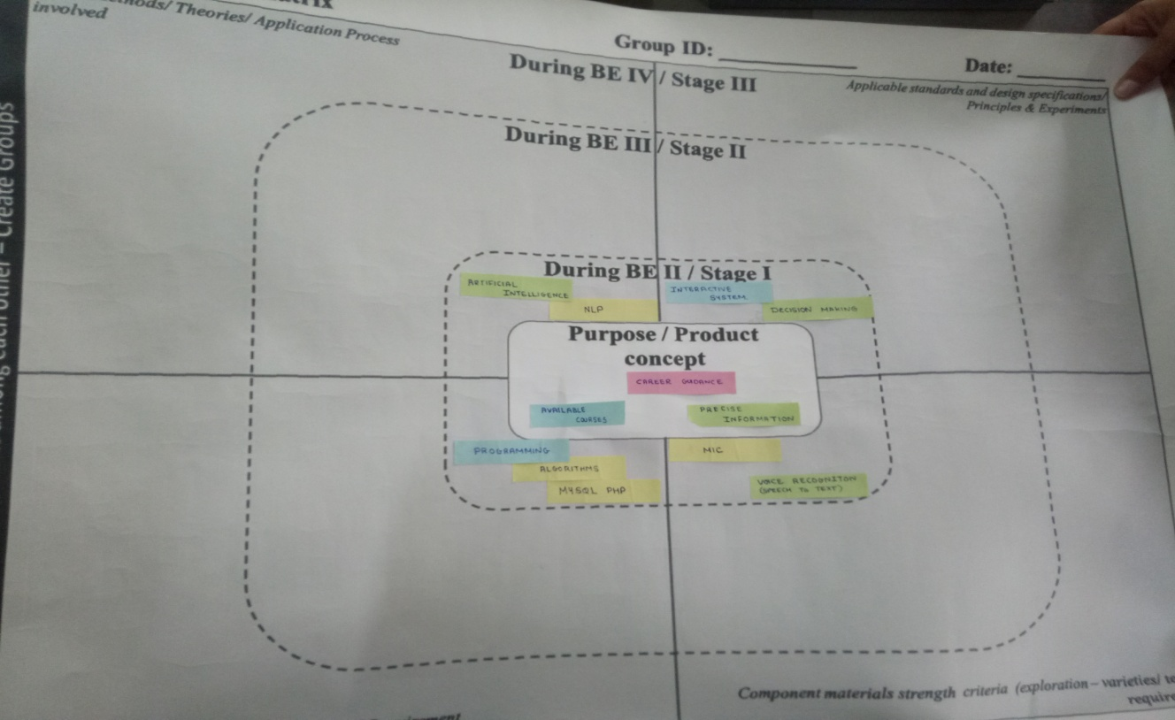

**PROTOTYPE**

**FLOW DIAGRAM**

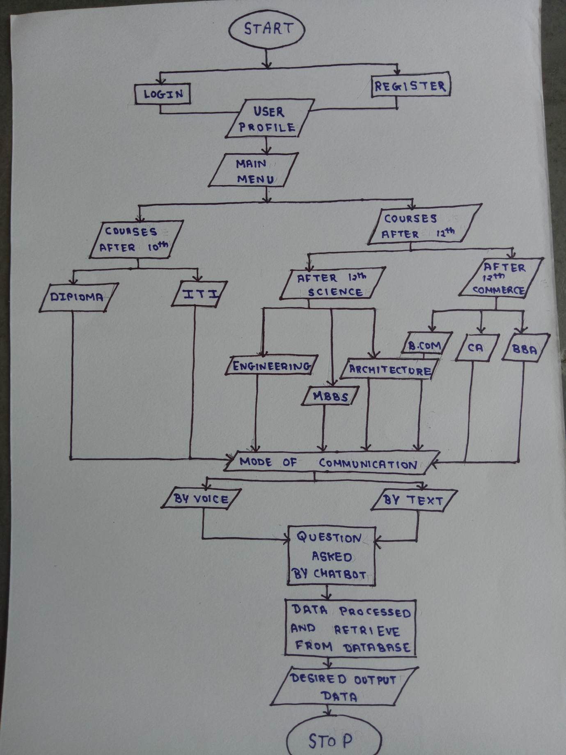

**CONCLUSION**

SO THE INTELLIGENT CHATBOT SYSTEM FOR CAREER COUNSELLING, WHICH WILL HELP USER IN CHOOSING THE RIGHT CAREER BY GIVING AN APPROPRIATE RESPONSE TO THE USER’S QUERY. IT IS AN INTELLIGENT SYSTEM THAT WILL THINK LIKE HUMAN BEINGS. THIS SYSTEM WILL BE HELPFUL IN REDUCING STRESS OF THE STUDENTS. DUE TO AN ACCURATE KNOWLEDGE BASE, QUICK ANSWERS WILL BE GIVEN TO THE USER.